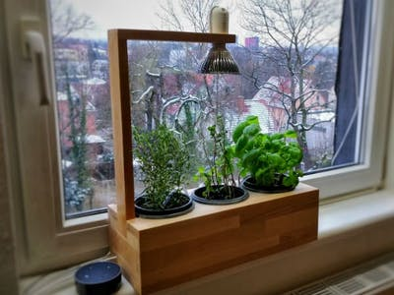  - October 14, 2021  Don’t Let Your Plants Die!  IEEE is offering a simple workshop to introduce innovative and useful ways to use your Arduino. This workshop will go through the steps of creating small system that will indicate you when your plant is thirsty! | No More Guessing!  ____  Just bring your Arduino board a RGB LED or three LED’s and that’s it!  ____  Enjoy getting to know other members of IEEE.  IEEE student chapter  UHART Hursey Center Makerspace  Thursday Oct.14,2021

